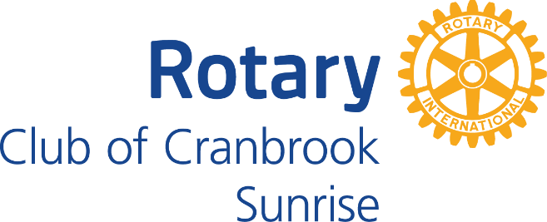
Clare Ramdin Scholarship
3rd or 4th or 5th Year
2023 Undergraduate Scholarship Application Form
Four - $2000 Scholarships to be Awarded
APPLICANT:
Name | First | Middle Initial | Last
Address | Street | City | Postal Code
Phone Number(s) | Cell | Home | Other
Email
NAME OF ALTERNATE PERSONAL CONTACT: (in case you cannot be reached)
Name | First | Middle Initial | Last
Address | Street | City | Postal Code
Phone Number(s) | Cell | Home | Other
Email
HOW DID YOU HEAR ABOUT THE CLARE RAMDIN AND SUNRISE ROTARY SCHOLARSHIP?
- Social Media (Facebook, Twitter, Instagram)
- A Friend
- A Rotarian
- University or College
- Other; __________________

HIGH SCHOOL INFORMATION:
Graduate High School (Circle One) | MBSS | HOME SCHOOL | PRIVATE SCHOOL (Name of School)
Year Graduated
LIST OF POST-SECONDARY INSTITUTIONS ATTENDED AND YEAR(S) ATTENDED:
Institution Name | Area of Study/ Major | Years attended
Institution Name | Area of Study/ Major | Years attended
Institution Name | Area of Study/ Major | Years attended
Institution Name | Area of Study/ Major | Years attended

PLEASE ATTACH THE FOLLOWING:
- A record of marks for the most recent 2 years of post-secondary education.
- A letter describing your educational goals
- A letter describing the reason for financial assistance
- A letter outlining your community service and volunteer work
- Any other information you feel would be helpful.

Any questions can be forwarded to Arlene Schroh, 250.421.7576 (duckworthcanada@yahoo.ca). Because of the number of applicants, only the successful applicants will be notified.

Thank you.

