Accommodated Students: RegisterBlast Instructions

Students with exam accommodations approved by the Accessibility Services Office will schedule their exams through RegisterBlast, our online exam registration system.

Students using RegisterBlast must register no later than one week prior to their midterm or lab exam (to the hour) or three weeks prior to the first day of final exams.

Important note: When using a public computer to register for your exams, use a New Incognito Window or New InPrivate Window on any web browser for privacy purposes.

Access RegisterBlast here: https://canada.registerblast.com/cotr/Exam/List

All the information used in this demonstration is made up. You must use your own information.

Step 1. Select Student Type

Step 2. Select Exam Type

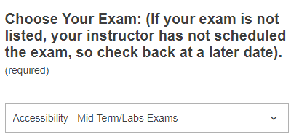

Step 3. Select Scheduled Exam

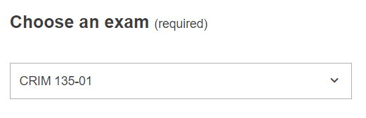

Step 4. Select Exam Date

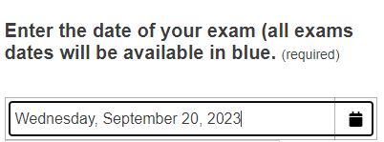

Step 5. Select Exam Time

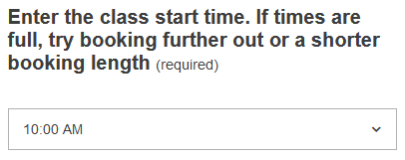

Step 6. Enter Personal Information (use your college email address)

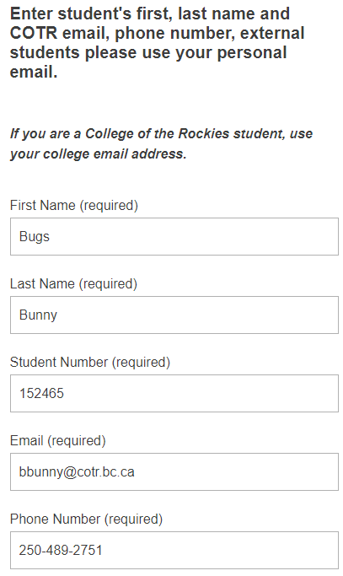

Step 7. Required extra information

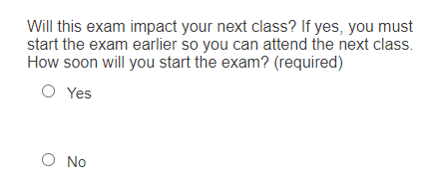

If you chose ‘No’ move on to the next question.

If you chose ‘Yes’ chose your start time.

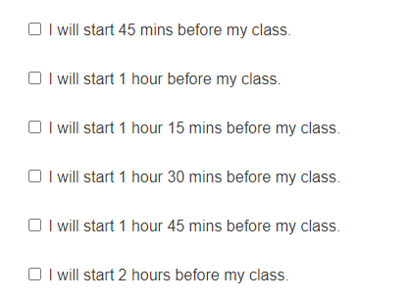

If you chose ‘Yes,’ go to the next Step 8

If you chose ‘No,’ provide your invigilator’s information.

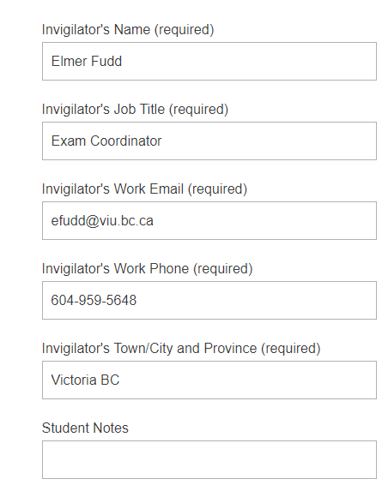
Student Notes is where you add any extra information the Testing Centre needs. Example: you and your instructor have approved a different time to write the exam.

Step 8 Click Add to Cart

Step 9 Click Complete Registration

